HEALTH PROMOTING SCHOOLS
NEWSLETTER
Content for Parent Newsletters
October 2022
INJURY PREVENTION

Concussion Awareness

September 25- October 1, 2022 was declared Concussion Awareness Week in B.C. To learn more about concussions the Concussion Awareness Training Tool (CATT) is available. This series of evidence-based online educational modules and resources addresses concussion recognition, diagnosis, treatment, and management. Learn more at Parent or Caregiver Course – CATT Online.

New Popping the Bubble Wrap podcast


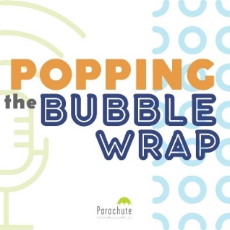
Parachute’s new podcast, Popping the Bubble Wrap, is focused on the “household safety officer”: the person in a family who worries about safety. Hosted by Parachute’s President and CEO Pamela Fuselli, each episode in our first season features a roundtable of parents who talk about an injury topic they worry about.

We released our first episode on Sept. 8 and a new episode will release every second Thursday until June 1, 2023.

The approach is informal, chatty and humourous. After the parents’ conversation, an expert joins Pamela to discuss what they heard, dispelling myths and giving advice or answering questions the parents may have. We also invite parents who listen to the podcast to share their questions with us by phone or email: 647-776-5123 or poppingthebubblewrap@parachute.ca

Popping the Bubble Wrap can be found anywhere you listen to podcasts such as Apple. Make sure to use the hashtag #PoppingTheBubbleWrap when you share the podcast with others on social media.

Check out our first episode and subscribe

NATURE CONNECTION

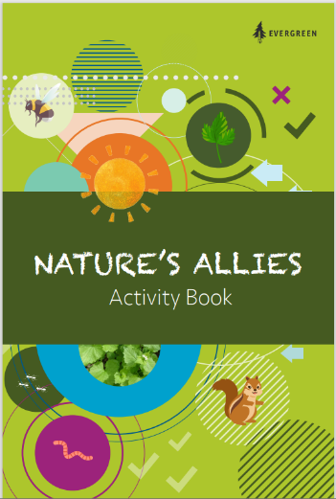
Downloadable and Printable Nature-based Activity Books for Children

Activity Books | Evergreen

ROAD SAFETY

Nominate your crossing guard starting Sept. 26

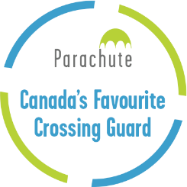
Our national contest honouring the best crossing guards in Canada returns in fall 2022, with nominations open Sept. 26 to Nov. 14, thanks to support from Desjardins Insurance.

Three exceptional school crossing guards will be chosen as winners, recognizing their extraordinary contributions to their communities.
The winning crossing guards receive $500 and the contest winner’s schools also receive $500.

Anyone, whether a parent, community member, teacher student or school staff member, can nominate their crossing guard. Just fill in the information required on the online nomination form. Entries can also include up to four attachments, such as photos or a scan of a child's drawing, to further illustrate the guard's impact on the community.

Read more about the contest and rules.

Vision Zero Road Safety Grants

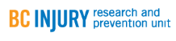
The British Columbia Vision Zero in Road Safety Program supports local governments, Indigenous community governments and non-government organizations (schools, PACs, road safety advocacy groups.) to make road safety improvements that result in reduced road user injuries and reductions in the severity of injuries.

Read more about the Vision Zero in Road Safety Grant Program.
The next round of applications will be November 1, 2022.
TOBACCO AND VAPOR PRODUCTS

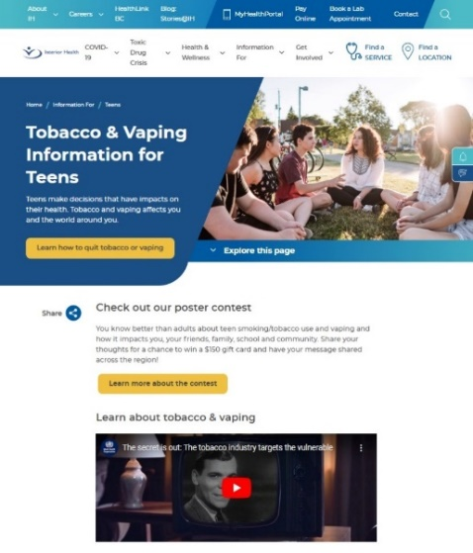
New! Tobacco and Vaping Webpage for Teens at IH

With so much information available, it can be tricky for young people to distinguish reliable sources from the noise on the web. To help youth stir away from all the misinformation, the TVR created a new webpage with information and resources for teens on tobacco and vaping. The Tobacco & Vaping Information for Youth page is located in the also new Teen Hub, where youth can find information about quitting tobacco and vaping, the Take a Breath Poster Contest and Youth Substance Use Services & Resources.

